Event with APFCB Auspices

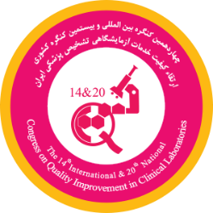

The 14th International & 20th National Congress on Quality Improvement in Clinical Laboratories

Organizer: Iranian Association of Clinical Laboratory Doctors

Date : 16-19 May 2023
Venue: Milad Tower International Conference center, Tehran, Iran
For more information please refer to link: http://www.iqctehran.ir

Event with APFCB Auspices
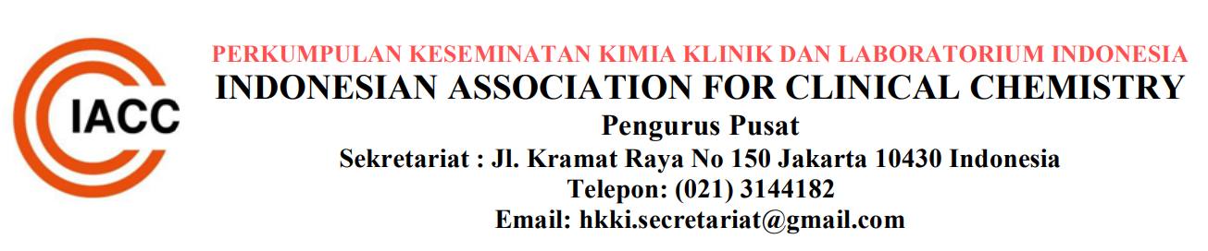

IFCC Visiting Lecture 2023 : Prof. Khosrow Adeli (IFCC President)

Organizer: The Indonesian Association for Clinical Chemistry (IACC)

Date : 23rd-25th March 2023
Venue: Prodia Tower, Jakarta, Indonesia
Congress website: www.hkki.org

